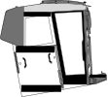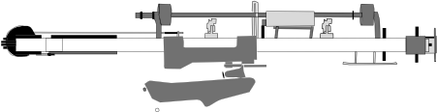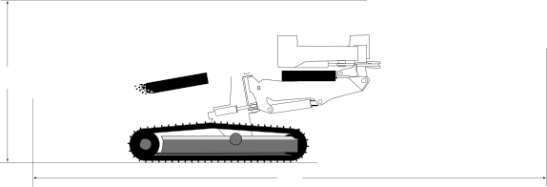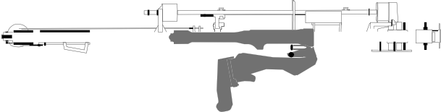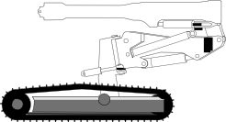H1 H2

L1 L2
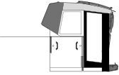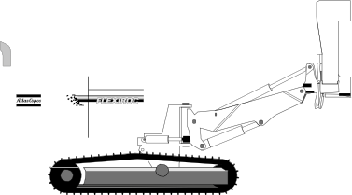Feed dumped LF Feed dumped SF

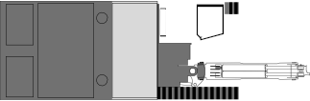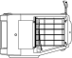3 000*
2 500

330

Side view
* Track widening kit

HEIGHT AND LENGTH
Standard unit excluding all options and drill steel | Metric | Imperial
FlexiROC D60 and  FlexiROC D65 LF | 23 700 kg (T3) | 52 250 lb
 | 24 100 kg (T4) | 53 130 lb
 | 22 600 kg (T3) | 49 820 lb
 | 23 000 kg (T4) | 50 700 lb

WEIGHT

FlexiROC D60 and
Long Feed (LF) dumped | Metric | Imperial
Height (H1) | 3 500 mm | 11’ 6’’
Length (L1) | 11 600 mm | 38’
Short Feed (SF) dumped | Metric | Imperial
Height (H2) | 3 500 mm | 11’ 6’’
Length (L2) | 11 350 mm | 37’ 2’’
Feed height | Metric | Imperial
Long feed (LF) | 11 600 mm | 38’
Short Feed (SF) | 9 400 mm | 31’

FlexiROC D65 SF

